Installing Citrix Receiver on Windows 7/10 (Internal PCs)
- If there are any older Citrix clients already installed on PC, download the “Citrix Client Cleanup Utility” at: http://atnyulmc.org/help-documentation/installation-downloads/CitrixInternal
Right click ReceiverCleanupUtility.exe and select “Run as administrator” (if you don’t see this option, just select “Open”).
Note: Needs Administrator privileges to run
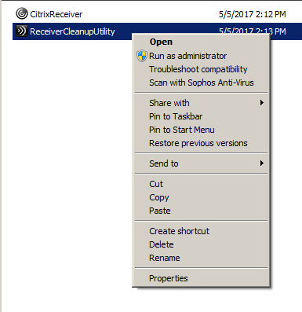
Press any key to start the cleanup/uninstall and type N when prompted at below question
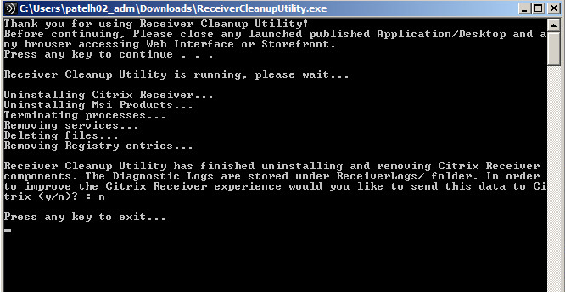
- Download the “Citrix Client for Windows” client at: http://atnyulmc.org/sites/default/files/CitrixReceiver49.exe
Right click CitrixReceiver.exe and then from the Downloads folder, right-click and select “Run as administrator” (if you don’t see this option, just select “open”)
Note: Needs Administrator privileges to install
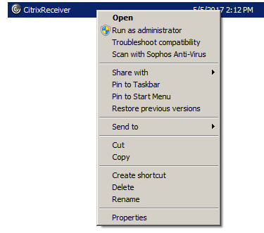
Click “Start” button
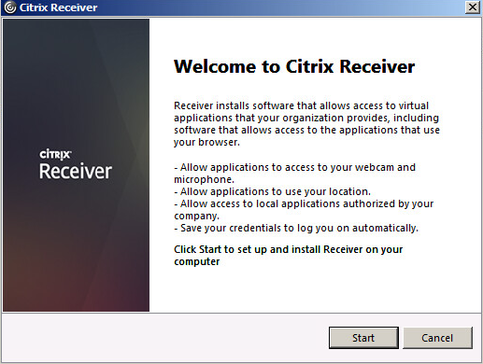

Click Accept and Next
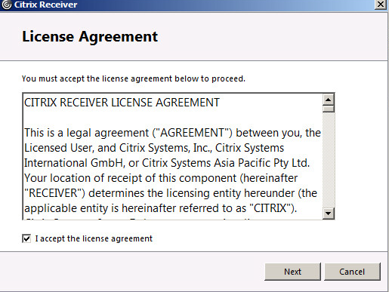
IMPORTANT: If your PC is part of NYUMC domain, check “Enable single sign-on” otherwise leave it unchecked
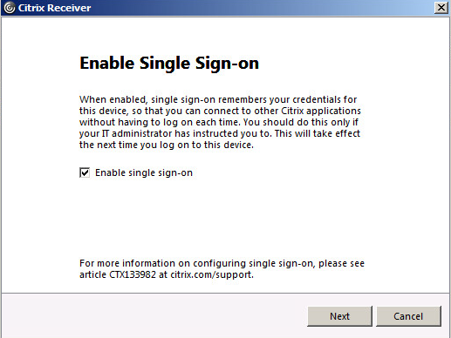

Select “No” below and click Install
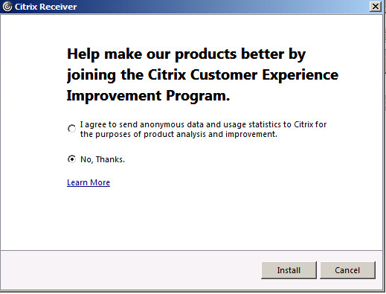
After Install is completed, click Finish
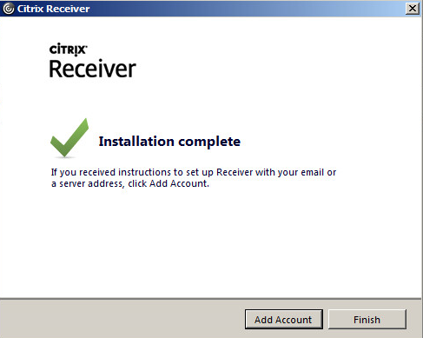
Restart your computer and Receiver should automatically configure the server URL to connect and should automatically login using your computer domain credentials used to logon to PC.
You should see Icons to Citrix applications you have permissions to launch.

If for some reason you require manual configuration of Citrix Receiver, please follow below steps.
Open Citrix Receiver and select “Accounts” from top right corner.
Click Add to add new account (server URL)
Type in URL: https://ctxstore.nyumc.org/citrix/ctxstore and click Add
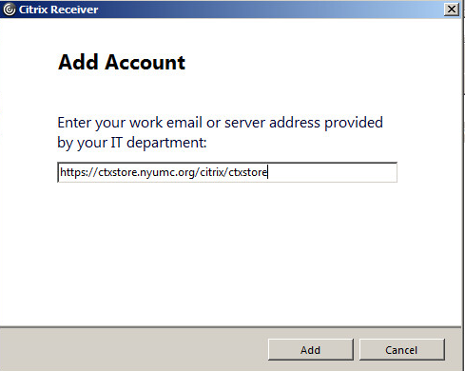
If the above URL doesn’t work, type in URL: https://ctxstore.nyumc.org/citrix/ctxstore/discovery
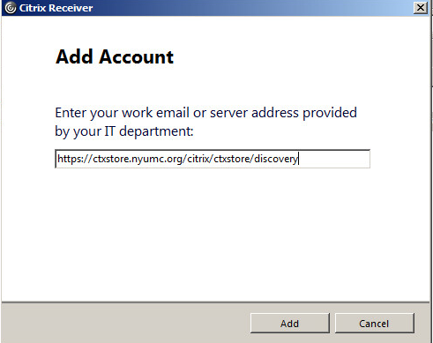

Type in your Kerberos ID/Pass (select Remember so you don’t have to type next time)
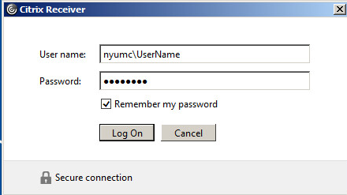
Note: If PC is not part of NYUMC domain, you may be prompted twice for initial login only.

You should now see Citrix Receiver open and Icons that you have permissions to.

